Nmap Vulnerability Assessment Report
Task Number: 2.1 Nmap Scan Report
Name: Jai Bhushan Rane
Intern ID: APSPL2641663
Date: 26-07-2026

1. Tools & Methodology
- Tool Used: Nmap v7.95
- Operating System Environment: Kali Linux on Oracle VirtualBox
- Target System: Metasploitable 2 (192.168.225.85)
- Scan Type: TCP SYN (Stealth) Scan, UDP Scan, Service Version Detection, OS Detection, and Full Comprehensive Scan

2. Commands Used
2.1 TCP SYN (Half-Open) Scan - nmap -sS 192.168.225.85 -oN tcp_scan.txt
- What it does: TCP SYN ("half-open") scan - sends SYN packets and watches for SYN/ACK responses to quickly find open ports without completing the full TCP handshake
- Purpose: Fast and stealthy port discovery
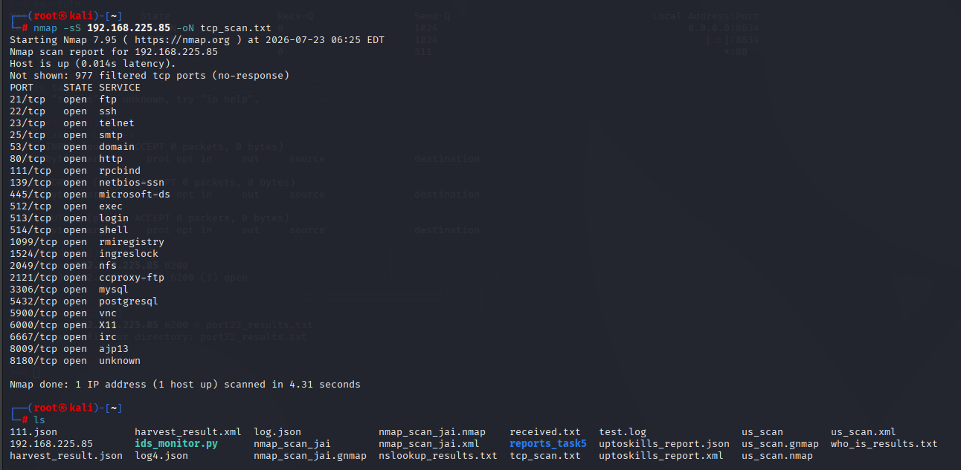
2.2 UDP Scan - nmap -sU 192.168.225.85 -oN udp_scan.txt
- What it does: UDP scan - sends UDP probes to discover UDP services
- Purpose: Identifies services that don't use TCP (slower but important for complete assessment)
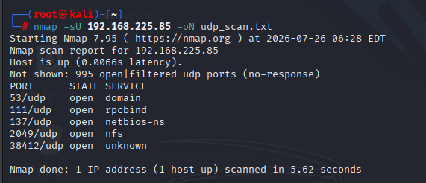

2.3 Service Version Detection - nmap -sV 192.168.225.85 -oN service_version.txt
- What it does: Version detection - probes open ports to identify service names and software versions
- Purpose: Maps version strings to known CVEs and vulnerabilities

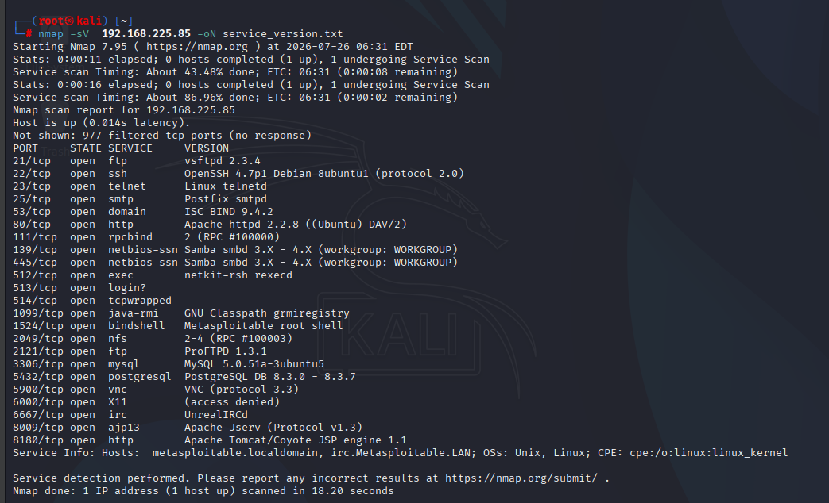

2.4 OS Detection - nmap -O 192.168.225.85 -oN os_detection.txt
- What it does: OS detection - analyzes packet responses, TTLs, and TCP/IP stack behavior to guess the target operating system
- Purpose: Identifies target OS for vulnerability matching
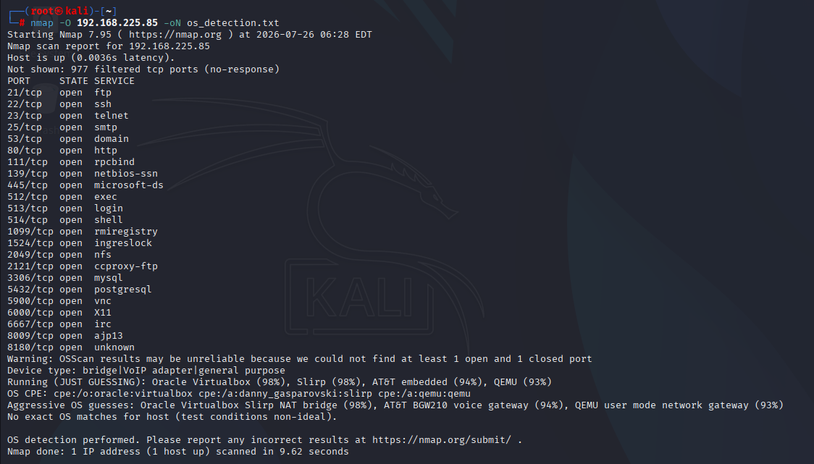
2.5 Full Comprehensive Scan - nmap -A -p- 192.168.225.85 -oA full_scan
- What it does: Aggressive scan combining OS detection, version detection, script scanning, and traceroute
- Purpose: Complete enumeration of all 65535 ports with detailed service information
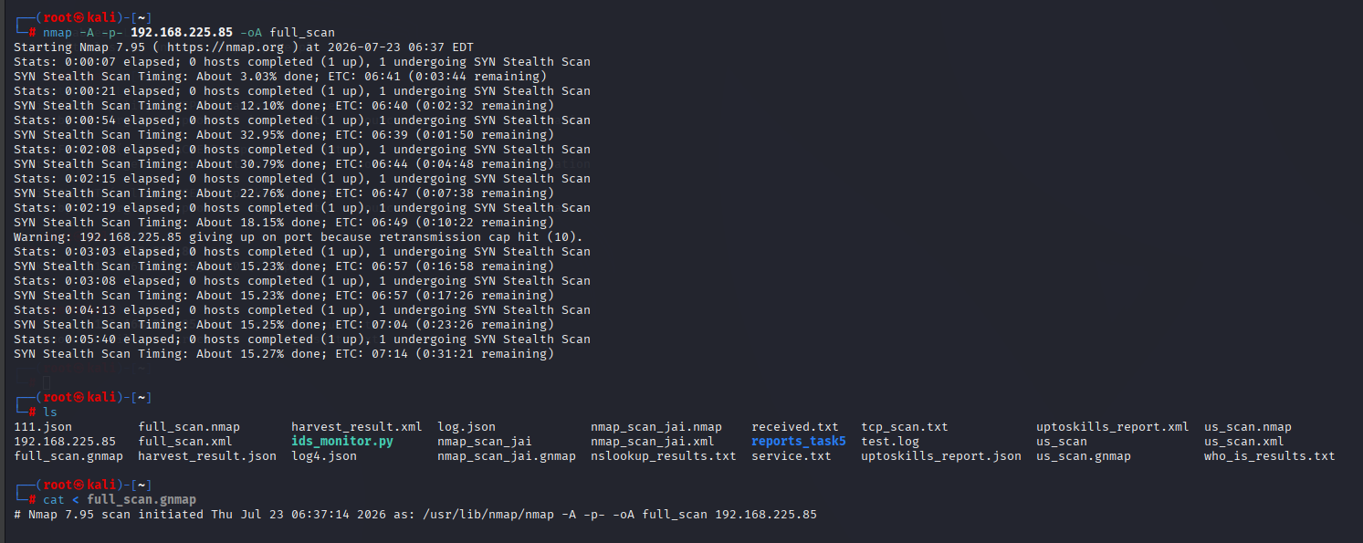
2.6 Banner Grabbing - nc -nv 192.168.225.85 21 then nc -nv 192.168.225.85 6200
- What it does: Connects to services to read their banners
- Purpose: Confirms service versions and discovers backdoor access
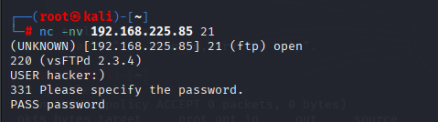
3. Scan Results & Findings
3.1 TCP SYN Scan Results (nmap -sS)
Command: nmap -sS 192.168.225.85 -oN tcp_scan.txt
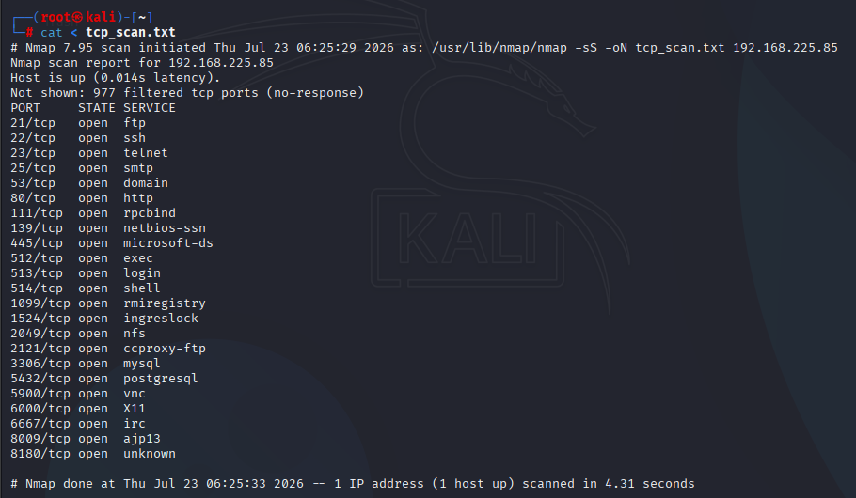
3.2 UDP Scan Results (nmap -sU)
Command: nmap -sU 192.168.225.85 -oN udp_scan.txt
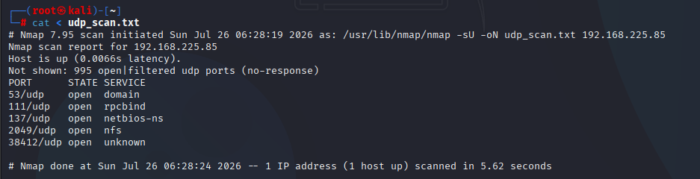
3.3 Service Version Detection Results (nmap -sV)
Command: nmap -sV 192.168.225.85 -oN service_version.txt
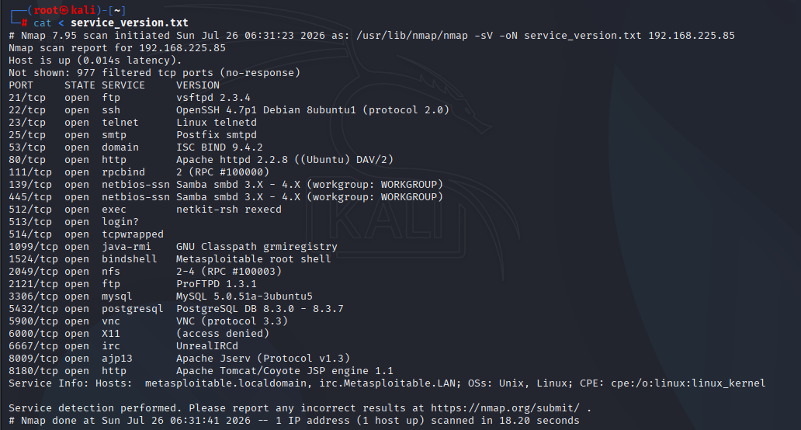
3.4 OS Detection Results (nmap -O)
Command: nmap -O 192.168.225.85 -oN os_detection.txt
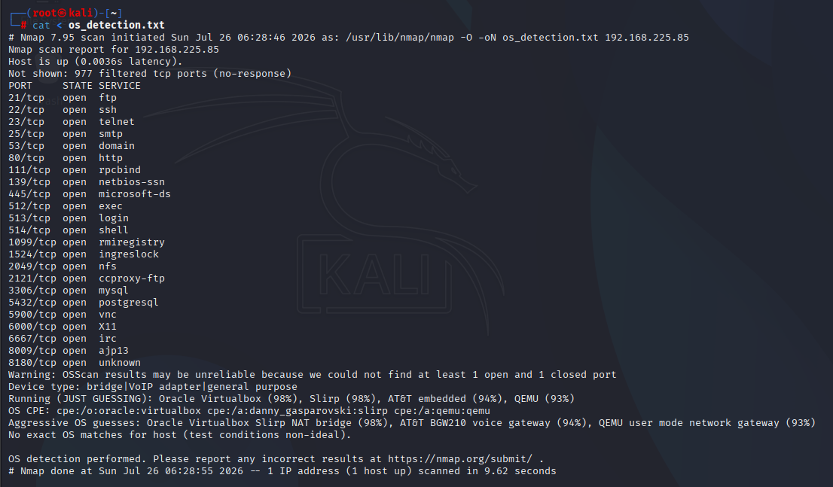
3.5 Banner Grabbing & Backdoor Discovery
FTP Banner: nc -nv 192.168.225.85 21
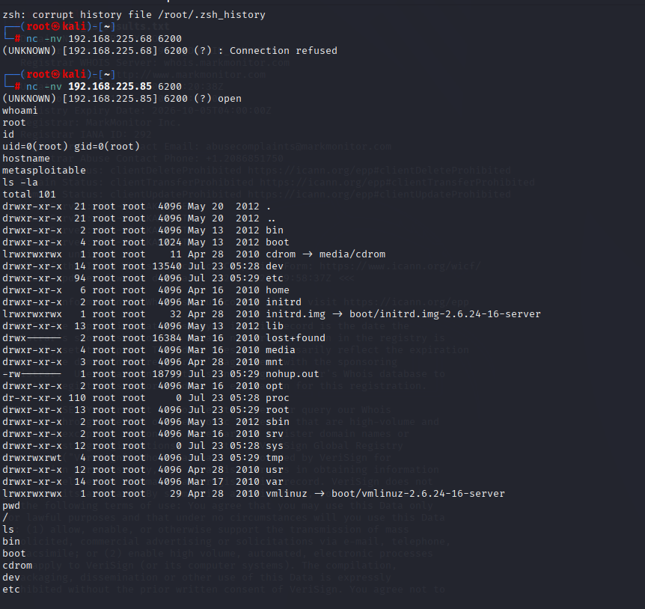
*#CRITICAL INTERPRETATION: The vsftpd 2.3.4 service contains a backdoor that opens port 6200. Connecting to this port grants unauthenticated root access to the entire system. This is a CVSS 10.0 (CRITICAL) vulnerability and represents complete system compromise.

4. Vulnerability Summary
4.1 Vulnerability Count by Severity
Severity | Count | Ports
Critical | 3 | 21 (vsftpd), 1524 (root shell), 6667 (UnrealIRCd)
High | 8 | 22, 80, 139, 445, 3306, 5432, 5900
Medium | 7 | 23, 53, 111, 512-514, 2049, 2121, 8009, 8180
Low | 2 | 25, 6000

4.2 Critical Vulnerabilities Identified
4.2.1 vsftpd 2.3.4 Backdoor (CVE-2011-2523)
Attribute | Detail
Port | 21/TCP
Service | vsftpd 2.3.4
CVSS Score | 10.0 (Critical)
Impact | Remote unauthenticated root access
Exploit | Connect to port 6200 after FTP login attempt
Proof | nc -nv 192.168.225.85 6200 → whoami = root

Description: An unauthenticated root shell is listening on port 1524. This allows immediate command execution with root privileges.
4.2.2 Metasploitable Root Shell (Port 1524)
Attribute | Detail
Port | 1524/TCP
Service | Ingresblock/bindshell
Impact | Instant root shell access
Severity | Crtical

Description: An unauthenticated root shell is listening on port 1524. This allows immediate command execution with root privileges.
4.2.3 UnrealIRCd Backdoor (Port 6667)
Attribute | Detail
Port | 6667/TCP
Service | UnreallRCd
Impact | Remote code execution
Severity | Critical

Description: UnrealIRCd contains a backdoor that allows remote attackers to execute arbitrary commands on the system.

4.3 High Severity Vulnerabilities
Port | Service | Version | Known Issues
22 | SSH | OpenSSH 4.7p1 | Multiple exploits, outdated (2007)
80 | HTTP | Apache 2.2.8 | Multiple CVEs, outdated (2008)
139/445 | SMB | Samba 3.X-4.X | Known exploits (EternalBlue-like)
3306 | MySQL | 5.0.51a-3ubuntu5 | Authentication bypass
5432 | PostgreSQL1 | 8.3.0-8.3.7 | Multiple vulnerabilities
5900 | VNC | Protocol 3.3 | Default Credentials possible

6. Recommendations
6.1 Critical Immediate Actions (Priority 1)
1. vsftpd 2.3.4 Backdoor (Port 21) - CRITICAL
- Action: Immediately remove or replace vsftpd 2.3.4
- Mitigation: Disable the FTP service entirely if not required. If required, upgrade to latest vsftpd version (3.0.5+)
- Hardening: Implement firewall rules to block port 6200 and restrict FTP access to trusted IPs only
- Validation: Rerun Nmap scan to confirm port 6200 is no longer accessible
2. Metasploitable Root Shell (Port 1524) - CRITICAL
- Action: Immediately identify and stop the process listening on port 1524
- Mitigation: This is likely a backdoor intentionally placed - investigate system integrity
- Hardening: Completely rebuild the system from trusted sources
3. UnrealIRCd Backdoor (Port 6667) - CRITICAL
- Action: Stop and remove UnrealIRCd service immediately
- Mitigation: If IRC is required, replace with a secure alternative
- Hardening: Block port 6667 at the firewall

6.2 High Priority Recommendations (Priority 2)
4. Outdated SSH Version (Port 22) - HIGH
- Action: Upgrade OpenSSH to latest version (8.x+)
- Mitigation: Disable password authentication, enforce key-based auth
- Hardening: Implement fail2ban, rate limiting, and restrict SSH access
5. Outdated Apache HTTP Server (Port 80) - HIGH
- Action: Upgrade Apache to version 2.4.x or newer
- Mitigation: Remove unnecessary modules, implement security headers
- Hardening: Run Apache with minimal privileges, chroot environment
6. Outdated MySQL Database (Port 3306) - HIGH
- Action: Upgrade to MySQL 5.7+ or migrate to MariaDB
- Mitigation: Remove default accounts, enforce strong passwords
- Hardening: Restrict access to localhost or trusted IPs only
7. Outdated PostgreSQL Database (Port 5432) - HIGH
- Action: Upgrade to PostgreSQL 13+ or latest LTS version
- Mitigation: Disable remote access if not required
- Hardening: Implement proper authentication, restrict network access
8. VNC Service (Port 5900) - HIGH
- Action: Change default password or implement SSH tunneling
- Mitigation: Consider replacing VNC with secure alternatives
- Hardening: Restrict VNC access to localhost only, use SSH forwarding
9. SMB Services (Ports 139, 445) - HIGH
- Action: Upgrade Samba to latest version
- Mitigation: Disable SMBv1, enforce SMBv3 with encryption
- Hardening: Restrict access to trusted networks only

6.3 Medium Priority Recommendations (Priority 3)
10. Telnet Service (Port 23) - MEDIUM
- Action: Disable Telnet and replace with SSH
- Reason: Telnet transmits credentials in plaintext
- Hardening: Remove telnet package entirely
11. DNS Service (Port 53) - MEDIUM
- Action: Ensure DNS is properly configured
- Mitigation: Disable recursion for external queries
- Hardening: Implement DNSSEC and rate limiting
12. RPC Service (Port 111) - MEDIUM
- Action: Restrict RPC access to localhost
- Mitigation: Use firewall rules to limit exposure
- Hardening: Disable if not required
13. ProFTPD (Port 2121) - MEDIUM
- Action: Upgrade to latest ProFTPD version
- Mitigation: Implement TLS encryption for FTP
- Hardening: Restrict access to trusted IPs
14. Tomcat (Port 8180) - MEDIUM
- Action: Remove default accounts, upgrade to latest
- Mitigation: Implement strong authentication
- Hardening: Disable unnecessary servlets, implement security constraints

6.4 General Security Recommendations
Network Segmentation:
- Place vulnerable systems (like Metasploitable 2) in isolated VLANs
- Use network segmentation to limit attacker movement
- Implement jump hosts/bastion hosts for administrative access
Firewall Policy:
- Implement deny-by-default inbound rules
- Only open ports required for business functions
- Limit source IP ranges to authorized hosts
Authentication & Credentials:
- Remove all default accounts
- Enforce strong password policies (12+ characters, complexity)
- Implement multi-factor authentication (MFA) where possible
- Rotate credentials regularly
Patch Management:
- Establish a formal patch management process
- Prioritize patching for critical and high severity vulnerabilities
- Test patches in staging before production deployment
- Maintain an asset inventory with version tracking
Monitoring & Alerting:
- Implement IDS/IPS (Snort, Suricata)
- Enable logging for all services
- Centralize logs with SIEM for analysis
- Set up alerts for suspicious scanning or authentication attempts
Host Hardening:
- Apply CIS benchmarks for the operating system
- Remove unnecessary packages and services
- Implement minimal privilege principle
- Enable automatic security updates where safe
Vulnerability Management:
- Conduct regular vulnerability scans (weekly/monthly)
- Perform penetration testing quarterly
- Re-scan after remediation to validate fixes
- Maintain a vulnerability tracking system
Retesting:
- After applying fixes, rerun all Nmap scans: nmap -sS -sV -O 192.168.225.85 -oN retest_scan.txt & nmap -sU 192.168.225.85 -oN retest_udp.txt
- Perform OpenVAS/Nessus vulnerability scan to validate remediation
- Document all remediation steps with timestamps
Documentation & Evidence:
- Keep all scan outputs with timestamps
- Document remediation steps and evidence
- Maintain an auditable trail for compliance
Ethics & Permissions:
- Only scan systems you own or have explicit permission to test
- Maintain test authorization records for auditors
- Follow responsible disclosure practices for discovered vulnerabilities

7. Conclusion
The Nmap vulnerability assessment of 192.168.225.85 (Metasploitable 2) revealed critical security issues that require immediate attention. The most severe finding is the vsftpd 2.3.4 backdoor (CVE-2011-2523), which provides unauthenticated root access to the entire system. Combined with the Metasploitable root shell on port 1524 and the UnrealIRCd backdoor on port 6667, the system is completely compromised.
Key Statistics:
- 23 open TCP ports discovered
- 5 open UDP ports discovered
- 3 CRITICAL vulnerabilities identified
- 8 HIGH severity vulnerabilities identified
- Multiple services are severely outdated (2007-2008 versions)
Overall Risk Rating: CRITICAL
The target system should NOT be exposed to any network environment without comprehensive hardening, patching, and security controls. The vulnerabilities identified could allow attackers to gain full control of the system, steal sensitive data, or use it as a pivot point for further attacks.
Recommended Next Steps:
- Isolate this system to a lab network immediately
- Apply critical patches or replace the entire system
- Re-scan after remediation to confirm fixes
- Conduct OpenVAS vulnerability scanning for detailed CVE mapping

8. Appendix
8.1 All Scan Commands Used
# TCP SYN Scan
nmap -sS 192.168.225.85 -oN tcp_scan.txt

# UDP Scan
nmap -sU 192.168.225.85 -oN udp_scan.txt

# Service Version Detection
nmap -sV 192.168.225.85 -oN service_version.txt

# OS Detection
nmap -O 192.168.225.85 -oN os_detection.txt

# Full Comprehensive Scan
nmap -A -p- 192.168.225.85 -oA full_scan

# Banner Grabbing
nc -nv 192.168.225.85 21
nc -nv 192.168.225.85 6200

8.2 Files Generated
- tcp_scan.txt
- udp_scan.txt
- service_version.txt
- os_detection.txt
- full_scan.nmap
- full_scan.xml
- full_scan.gnmap

8.3 CVEs Referenced
CVE | Service | Severity
CVE-2011-2523 | vsftpd 2.3.4 | CRITICAL (10.0)
CVE-2007-5498 | OpenSSH 4.7p1 | HIGH
CVE-2008-0455 | Apache 2.2.8 | HIGH
CVE-2008-1800 | Samba 3.x | HIGH
CVE-2008-2079 | MySQL 5.0.51a | HIGH
CVE-2008-0176 | PostgreSQL 8.3.x | HIGH
CVE-2010-2075 | UnrealIRCd | CRITICAL

Report Prepared By: Jai Bhushan Rane
Date: 26-07-2026
Intern ID: ASPL2518045
Classification: INTERNAL - LAB USE ONLY

